DAYANANDA SAGAR UNIVERSITY

**KUDLU GATE, BANGALORE – 560068**



**Bachelor of Technology   
  
in**

**COMPUTER SCIENCE AND TECHNOLOGY**

**Project Phase-II Report**

**(20CT4802)**

**IoT-Enhanced Tomato plant cultivation with machine learning**

By

**ABHAS AGNIHOTRI - ENG20CT0001**

**DEEPAK B G - ENG20CT0009  
M NIKHIL GUPTHA - ENG20CT0015**

**SHASHIKALA M S - ENG20CT0025**

**Under the supervision of  
  
PROF. NIVETHA NRP,  
Assistant Professor  
 Department of Computer Science and Technology**



**Department of Computer Science & Technology**

Kudlu Gate, Bangalore – 560068 Karnataka, India

**CERTIFICATE**

This is to certify that the work titled **“ IoT-Enhanced Tomato plant cultivation with machine learning”** is carried out by **Abhas Agnihotri (ENG20CT0001), Deepak B G (ENG20CT0009), M Nikhil Guptha (ENG20CT0015), Shashikala M S (ENG20CT0025)** Bonafide students of Bachelor of Technology in Computer Science and Technology at the School of Engineering, Dayananda Sagar University, Bangalore in partial fulfillment for the award of degree in Bachelor of Technology in Computer Science and Technology, during the year **2023-2024**.

___________________________ __________________________

**Nivetha NRP Dr. M Shahina Parveen**

Associate Professor, Dept. of CST Chairperson,Dept. of CST,

School of Engineering, School of Engineering,

Dayananda Sagar University. Dayananda Sagar University.



**Department of Computer Science & Technology**

Kudlu Gate, Bangalore – 560068 Karnataka, India

**DECLARATION**

WeAbhas Agnihotri (ENG20CT0001), Deepak B G (ENG20CT0009), M Nikhil Guptha (ENG20CT0015), Shashikala M S (ENG20CT0025) ,are students of the seventh semester B.Tech in Computer Science and Technology, at School of Engineering, Dayananda Sagar University, hereby declare that the project phase-II project titled “ IoT-Enhanced Tomato plant cultivation with machine learning ” has been carried out by us and submitted in partial fulfillment for the award of degree in Bachelor of Technology in Computer Science and Technology during the academic year 2023-2024.

Student Signatures

Name1: Abhas Agnihotri

USN: ENG20CT0001

Name2: Deepak B G

USN: ENG20CT0009

Name3: M Nikhil Guptha

USN: ENG20CT0015

Name4: Shashikala M S

USN: ENG20CT0025

Place: Bangalore

Date:

**ACKNOWLDENEMENT**

*It is a great pleasure for us to acknowledge the assistance and support of many individuals who have been responsible for the successful completion of this project work.*

*First, we take this opportunity to express our sincere gratitude to School of Engineering, Dayananda Sagar University for providing us with a great opportunity to pursue our Bachelor’s degree in this institution.*

*We would like to thank* ***Dr. Udaya Kumar Reddy K R, Dean, School of Engineering & Technology, Dayananda Sagar University*** *for his constant encouragement and expert advice.*

*It is a matter of immense pleasure to express our sincere thanks to* ***Dr. M Shahina Parveen, Chairperson****,* ***Computer Science and Technology****,* ***Dayananda Sagar University,*** *for providing right academic guidance that made our task possible.*

*We would like to thank our* ***Project Coordinator Dr. Bhaskar Venugopalan*** *and* ***Prof. Chithambarathanu M*** *as well as all the staff members of Computer Science and Technology for their support. We are also grateful to our family and friends who provided us with every requirement throughout the course.*

*We would like to thank our guide* ***Prof*** ***Nivetha NRP****,* ***Assistant Professor****,* ***Dept. of Computer Science and Engineering****,* ***Dayananda Sagar University****, for sparing her valuable time to extend help in every step of our project work, which paved the way for smooth progress and fruitful culmination of the project.*

*We would like to thank one and all who directly or indirectly helped us in the Project work.*

**ABSTRACT**

The integration of IoT and machine learning in tomato cultivation marks a significant advancement, addressing critical challenges in soil moisture monitoring, nutrient management, and pest detection. These aspects are pivotal for maximizing crop yield and sustainability. Through IoT-enabled sensors like soil moisture and NPK sensors connected to microcontrollers such as NodeMCU and Arduino Uno, real-time data on soil conditions and nutrient levels are gathered. This data empowers farmers with actionable insights for timely interventions and efficient resource allocation.

Key functionalities of this integrated system include dynamic soil moisture detection and regulation, ensuring optimal hydration levels throughout various plant growth stages. Additionally, the system facilitates precise soil nutrient management through NPK sensors and RS485 modules, offering valuable insights for nutrient optimization strategies. Furthermore, pest detection is enhanced using a camera module and ML model, enabling accurate identification of diseases and pests. This capability allows for proactive pest management measures, contributing to improved crop health and productivity.

This holistic approach represents a significant step towards modernizing agricultural practices, emphasizing sustainability, efficiency, and productivity in tomato cultivation. The scalable solutions offered by this integrated system have the potential to enhance overall crop management and contribute significantly to food security initiatives.

**Keywords: Internet of Things (IoT), Convolutional Neural Network (CNN), InceptionV3, Soil Moisture Monitoring, Soil Nutrient Management, Pest Detection.**

LIST OF FIGURES

|  |  |  |
| --- | --- | --- |
| **Fig. No.** | **Description of the figure** | **Page No.** |
| 5.1 | System architecture |  |
| 6.1 | Soil moisture monitoring and pumping |  |
| 6.2 | Moisture of soil and status of pump displayed in Blynk app. |  |
| 6.3 | Soil nutrients monitoring and pumping |  |
| 6.4 | Nutrients level in soil and Ratios of NPK at different growth phases in Blynk app. |  |
| 6.5 | Pest Detection and identification workflow. |  |
| 6.6 | Different types of pests of tomato plant. |  |
| 6.7 | Training and Validation accuracy |  |
| 6.8 | Outcome of the predicted disease is sent to the user via SMS. |  |

**TABLE OF CONTENTS**

|  |  |
| --- | --- |
|  | **Page No.** |
| **Certificate** | **i** |
| **Declaration** | **ii** |
| **Abstract** | **iii** |
| **List of Figures** | **iv** |
| **List of Tables** | **v** |
| **List of Abbreviations** | **Vi** |
| 1. **Introduction**   **1.1 Soil Moisture Monitoring and Automated Pumping**  **1.2 Soil Nutrient Management**  **1.3 Pest Detection and Management** |  |
| 1. **Literature Survey** |  |
| 1. **Requirement Specification** **3.1. Soil Moisture Monitoring and Pumping Tools**   **3.2. Soil Nutrients Detection Tools**  **3.3 Pest Detection Tools** |  |
| **4. Problem Definition**  **4.1 Problem Statement**  **4.2 Relevance of the Problem** |  |
| **5. System Architecture** |  |
| **6. Implementation** |  |
| **7. Conclusion** |  |
| **References** |  |

**CHAPTER 1**

**INTRODUCTION**

Tomato cultivation stands as a cornerstone of agricultural practices worldwide, accounting for a substantial portion of food production, economic stability, and global food security. In the context of India, a prominent player in tomato production, the significance of leveraging advanced technologies cannot be overstated. India ranks among the top tomato-producing countries globally, with an estimated production of over 20 million metric tons annually, highlighting the critical role of tomatoes in the nation's agricultural landscape.

In recent years, there has been a notable shift towards adopting cutting-edge technologies to revolutionize traditional agricultural methods. This transformation is particularly evident in the realm of tomato cultivation, where the integration of Internet of Things (IoT) devices and machine learning (ML) algorithms has emerged as a game-changer. These technologies offer unparalleled opportunities to optimize crop yield, enhance produce quality, and ensure sustainable farming practices.

**1.1 Soil Moisture Monitoring and Automated Pumping**

Soil moisture is a critical factor influencing plant growth, nutrient uptake, and overall crop health. In traditional farming, manual soil moisture assessment and irrigation practices often result in water wastage or inadequate hydration for plants. The introduction of IoT-based soil moisture monitoring systems has transformed this aspect of agriculture. These systems employ advanced sensors capable of accurately measuring soil moisture levels in real-time. By continuously monitoring soil moisture, farmers can optimize irrigation schedules, ensuring that plants receive the right amount of water at the right time. This not only conserves water but also promotes healthy root development, reduces water stress, and enhances crop resilience to environmental fluctuations.

**1.2 Soil Nutrient Management**

Nutrients such as Nitrogen (N), Phosphorus (P), and Potassium (K) are essential for plant growth, flowering, fruiting, and overall productivity. Imbalances or deficiencies in these nutrients can lead to stunted growth, nutrient-related disorders, and reduced crop yields. Traditional nutrient management practices often rely on manual observation or generalized fertilization schedules, which may not meet the specific needs of different crops or growth stages. IoT-enabled nutrient management systems address this challenge by integrating NPK sensors that monitor nutrient levels in the soil. By delivering the right nutrients in the right quantities, IoT-based nutrient management enhances plant vigor, optimizes yield potential, and minimizes nutrient wastage.

**1.3 Pest Detection and Management**

Pests and diseases pose significant threats to crop health and yield. Traditional pest management approaches rely heavily on pesticide applications, which can be costly, environmentally harmful, and sometimes ineffective due to improper timing or dosage. IoT and ML technologies offer a more sustainable and proactive approach to pest detection and management. ML algorithms trained on image data can accurately identify pest infestations, leaf diseases, and other abnormalities in crops. Integrated with IoT systems, these ML models can trigger automated alerts or responses when pests or diseases are detected. By enabling early detection and targeted interventions, IoT-based pest management systems reduce reliance on chemical pesticides, minimize crop damage, and promote ecological balance in agricultural ecosystems.

Overall, the integration of IoT, ML, and advanced sensors in tomato cultivation represents a paradigm shift towards precision agriculture. These technologies empower farmers with real-time data insights, automation capabilities, and decision support tools, enabling them to optimize resource usage, improve crop quality, and sustainably meet the growing demand for food globally.

**CHAPTER 2**

**LITERATURE REVIEW**

**1. IoT-Enabled Smart Drip Irrigation System Using ESP3,2023**

*Journal*MDPI

*Authors*Gilroy P. Pereira, Mohamed Z. Chaari, and Fawwad Daroge

*Problem mentioned*

This paper introduces a Smart Drip Irrigation System to address the challenge of efficient water management in agriculture. The solution is an IoT-enabled system that automates irrigation based on soil moisture, temperature, and humidity, optimizing water usage for plant growth.

*Tools Used*

1. Microcontroller: ESP32
2. Moisture Sensor: DFRobot SEN0308
3. Temperature Sensor: DS18B20
4. Air Humidity Sensor: DHT22
5. Water Flow Sensor: FS300A G3/4 Inch
6. Solenoid Valve: Hunter PGV-100G (24VAC)
7. Relay: Used as an electrically controlled switch
8. Step-Down Voltage Regulator: To supply power to the ESP32
9. Acrylic Container: Custom-made for housing the system
10. Soil: All-purpose potting soil with specific characteristics.

*Results and Discussion*

Primary tests in the laboratory validated the functionality of various sensors, solenoid valve, and firmware. Comparison of sensor readings to weather forecasts demonstrated accurate measurements, particularly in air temperature and humidity. Outdoor testing of the solenoid valve confirmed the system's effectiveness in an outdoor environment. Field testing of the smart drip irrigation system showcased successful growth of spring onions, ensuring adequate water supply and automated irrigation based on sensor readings.

*Knowledge Acquired*

The paper provides insights into building an IoT-enabled smart drip irrigation system for precision agriculture, emphasizing automation and control using a microcontroller. It discusses calibration, sensor validation, and field testing, offering real-time monitoring and control through a Blynk IoT dashboard.

**2. A Literature Review on Automatic Watering of Plants,2022**

*Journal/Conference*

IJCRT

*Author*Mani Bansal, Abhay Pandey, Mandvi Singh, Nivesh Sharma, Ms. Neha, Raj Kumar Goel

*Problem Statement and Solution*

In this literature review, we explore the challenges associated with manual plant watering and the benefits of implementing automatic plant watering systems. The problem lies in the time and effort required for regular plant care, especially in a world where people have increasingly busy lives. The solution obtained involves investigating various automatic plant watering systems and assessing their effectiveness, cost-efficiency, and impact on plant health.

*Algorithm Used*

This literature review does not directly involve the use of algorithms since it primarily focuses on summarizing and analyzing existing research. However, some of the automatic plant watering systems discussed in the review may employ algorithms for soil moisture measurement and water delivery.

*Tools Used*

1. Soil moisture sensors
2. Microcontrollers (e.g., Arduino)
3. Water pumps
4. Solenoid valves
5. Cloud-based monitoring
6. control systems

*Result and Discussion*

The results section will summarize the key findings from the literature review. These findings may include the benefits of automatic watering, such as improved plant health and reduced water usage. It may also discuss the limitations and challenges associated with certain systems. The discussion section will provide insights into the implications of the results and highlight any gaps in the existing research.

*Knowledge Acquired*

The knowledge acquired from this literature review encompasses a comprehensive understanding of the state of the art in automatic plant watering systems. Readers will gain insights into the advantages and disadvantages of various approaches, the impact on plant growth, and the potential for widespread adoption of such systems.

**3. Monitoring of Soil Nutrients Using Soil NPK Sensor and Arduino, 2023**

*Journal*

Ecology, Environment and Conservation Journal

*Author*

• G. L. Lenin Kumar

• M. Srivani

• Md. Tabassum Nishath

• T. Akhil • Arugula Naveen

• K. Charith Kumar

*Problem mentioned*

The paper addresses the challenge of accurately monitoring soil nutrients in agricultural fields, crucial for optimizing crop yield and ensuring sustainable farming practices. It proposes the integration of a Soil NPK Sensor with Arduino technology as a solution to provide real-time data on essential nutrients – nitrogen, phosphorus, and potassium – in the soil. By utilizing this sensor-based approach, the study aims to overcome the limitations of traditional soil testing methods, which are often time-consuming, labor-intensive, and costly.

*Tools Used*

1. Soil NPK Sensor: A 3-in-1 fertility sensor designed to detect the content of nitrogen, phosphorus, and potassium in the soil with high precision and accuracy.
2. Arduino Technology: The Arduino platform is utilized to interface with the soil NPK sensor, enabling data collection and analysis in real-time.
3. MAX485 TTL to RS485 Converter Module: This module facilitates communication between the Arduino board and the soil NPK sensor via RS485 protocol.
4. OLED Display Module: A monochrome OLED display is used to visualize the sensor data, providing an intuitive interface for users.

*Results and Discission*

The research conducted experiments at various data points to evaluate the performance of the soil NPK sensor integrated with Arduino technology. The results indicate that the sensor system provides nutrient levels (NPK) in soil that closely match values obtained from laboratory measurements. This suggests that the sensor-based approach offers high accuracy and efficiency in monitoring soil nutrients, making it a cost-effective solution for continuous soil nutrient monitoring in agricultural fields.

**4. Field application of precise IoT-based soil testing and fertilizer recommendation system in tomato, 2023**

*Journal*

The Pharma Innovation Journal

*Authors*

Bijaylakhmi Goswami and Naseema Rahman

*Problem mentioned*

The paper discusses the challenges faced in traditional soil testing and fertilizer recommendation methods for tomato cultivation. It presents a solution through the implementation of an IoT-based system that offers precise soil testing and personalized fertilizer recommendations tailored to the specific needs of tomato plants. This approach aims to optimize nutrient utilization, improve yield, and enhance overall crop quality.

*Algorithm Used*

The paper incorporates advanced algorithms for data analysis and decision-making within the IoT-based system. Details regarding the algorithms used will be elaborated in the methodology section.

*Tools Used/Implemented*

The implementation of the IoT-based soil testing and fertilizer recommendation system includes a mix of hardware and software tools. These tools encompass sensors for soil parameter measurement, data processing units, communication modules for IoT connectivity, and software for data analysis and recommendation generation.

*Results and Discussion*

The results of the study demonstrate significant improvements in tomato yield and quality through the implementation of the IoT-based soil testing and fertilizer recommendation system compared to traditional methods. Quantitative data analysis reveals a notable increase in yield per hectare, with an average of 20% higher yield observed across multiple test plots. This increase is attributed to the system's ability to precisely monitor soil nutrient levels and provide tailored fertilizer recommendations, leading to optimized nutrient utilization by tomato plants. Additionally, the IoT system contributes to better resource management by reducing fertilizer usage by 15% on average while maintaining or even enhancing crop productivity. This reduction in fertilizer application not only results in cost savings for farmers but also contributes to environmental sustainability by minimizing nutrient runoff and potential soil degradation.

*Knowledge Acquired*

Through the research and implementation of the IoT-based system, valuable insights into optimizing tomato cultivation practices using technology are gained. This includes understanding the importance of real-time data monitoring.

**5. A review on the seasonal succession and management of key insect pests infesting tomatoes**, **2023**

*Journal*

IEEEInternational Conference on Image Processing (ICIP)

*Author*

Soniya Dhanda

Surender Singh Yadav

Anil Jakhar

Sonu Kumari

*Problem mentioned*

The paper addresses the challenge of accurately segmenting medical images, particularly in the context of tumor detection. It compares various image segmentation algorithms to identify the most effective approach for medical image analysis.

*Algorithm Used*

The paper evaluates several segmentation algorithms, including K-means clustering, Watershed transform, and Convolutional Neural Networks (CNNs).

*Tools Used*

MATLAB, Python with TensorFlow and Keras for implementing CNNs.

*Results and Discussion*

The results demonstrate that CNN-based approaches outperform traditional methods like K-means clustering and Watershed transform in terms of segmentation accuracy and robustness, especially in complex medical images with varying levels of noise and artifacts. The paper discusses the strengths and limitations of each algorithm and provides insights into their performance metrics

*Knowledge Acquired*

Through this study, researchers gained a deeper understanding of the strengths and weaknesses of different image segmentation algorithms for medical image analysis. They acquired knowledge about the importance of selecting appropriate algorithms based on the characteristics of the images and the specific requirements of the medical application. Additionally, they gained insights into the potential of CNNs for improving segmentation accuracy in challenging medical imaging tasks.

**6. Deep Feature Extraction for Detection of Tomato Plant Diseases and Pests based on Leaf Images**, **2021**

*Journal*

Celal Bayar University Journal of Science.

*Author*

Yahya Altuntaş,

Adnan Fatih Kocamaz.

*Problem mentioned*

The paper addresses the challenge of detecting tomato plant diseases and pests accurately and efficiently to prevent yield and quality losses in agriculture. Traditional methods of visual observation by experts are labor-intensive and prone to errors. The authors propose a solution using deep learning techniques, specifically utilizing pre-trained convolutional neural network (CNN) models as feature extractors and a support vector machine (SVM) classifier. By extracting deep features from leaf images and training the classifier, the system achieves high accuracy in classifying different diseases and pests affecting tomato plants.

*Algorithm Used*

The study employs pre-trained CNN models (AlexNet, GoogLeNet, and ResNet-50) as feature extractors and an SVM classifier for training and classification tasks.

*Tools Used*

The experiments are conducted using the MATLAB 2019b programming environment. The dataset used for training and testing is a subset of the PlantVillage dataset containing images of diseased and healthy tomato leaves.

*Results and Discussion*

The experimental results demonstrate promising outcomes, with the proposed method achieving an overall accuracy rate of 96.99% in detecting tomato plant diseases and pests. Comparison with related studies in the literature indicates the superiority of the proposed approach. The authors discuss the implications of their findings and highlight the potential for further research to enhance classification performance and evaluate models under field conditions.

*Knowledge Acquired*

The paper provides valuable insights into the application of deep learning techniques for agricultural purposes, particularly in the domain of plant disease and pest detection. It underscores the importance of leveraging advanced technologies to address significant challenges in agriculture, ultimately contributing to food security.

**CHAPTER 3**

**REQUIREMENT SPECIFICATIONS**

**3.1. Soil Moisture Monitoring and Pumping Tools**

**3.1.1. AB054 Soil Moisture Sensor**

The AB054 Soil Moisture Sensor is a capacitive type sensor designed for monitoring soil moisture levels in agricultural applications. It operates within a voltage range of 3.3V to 5V and provides an analog output that is proportional to the moisture content in the soil. This sensor is known for its accuracy and typically covers a sensing range from 0% to 100%. It interfaces with microcontrollers like the NodeMCU, making it suitable for integration into IoT-based projects.

**3.1.2. Microcontroller (NodeMCU)**

The NodeMCU microcontroller is based on the ESP8266 chip and features a built-in Wi-Fi module, allowing for wireless data transfer. Operating at 3.3V DC, the NodeMCU is compatible with the Arduino IDE for programming and offers multiple GPIO pins for sensor interfacing. It serves as the central processing unit in the system, collecting data from the soil moisture sensor and controlling the water pump based on the moisture readings.

**3.1.3. Water Pump**

The water pump is an electric pump that operates at either 12V or 24V DC, delivering water into the soil based on commands from the NodeMCU. It is essential for maintaining optimal soil moisture levels and ensuring proper hydration of plants. The pump's flow rate and pressure rating determine its performance in pushing water through the irrigation system.

**3.1.4. Relay Module**

The relay module acts as a switch for high-voltage devices using low-voltage signals from the NodeMCU. It is compatible with 3.3V or 5V DC and has a specified switching capacity, usually around 220V AC and 10A. The relay module controls the operation of the water pump, turning it on or off as per the moisture level thresholds set in the system.

**3.1.5. Blynk**

Blynk is a mobile and web application platform designed for IoT projects. It provides real-time monitoring and control capabilities, allowing users to remotely monitor soil moisture levels and pump status. With customizable widgets and an intuitive interface, Blynk facilitates easy data visualization and management, enabling users to set thresholds and data regarding the soil moisture levels and irrigation system status.

**3.2. Soil Nutrients Detection Tools**

**3.2.1. NPK Sensor**

This specialized sensor is designed to measure the concentrations of nitrogen (N), phosphorus (P), and potassium (K) within the soil. It employs advanced technology to provide precise and reliable readings of these essential nutrients, facilitating effective nutrient management for optimal plant growth and development.

**3.2.2. Voltage Regulator:**

The voltage regulator is a vital component that ensures a stable and consistent power supply to the NPK sensor, Arduino Uno, LCD screen. By regulating the voltage output, it prevents fluctuations in power that could otherwise affect the accuracy and reliability of the sensor's readings. This stable power source is essential for obtaining accurate nutrient level data over time.

**3.2.3. RS485 module**

The RS485 module acts as a communication bridge between the NPK sensor and the Arduino Uno microcontroller. It facilitates the transmission of data from the NPK sensor, which operates on a different communication protocol, to the Arduino Uno, which processes and interprets this data.

**3.2.4. Arduino Uno:**

Serving as the intermediary between the NPK sensor and the NodeMCU, the Arduino Uno microcontroller plays a crucial role in data acquisition and processing. It receives raw data from the sensor, processes it into usable information, and prepares it for transmission to the NodeMCU. Its processing capabilities enable efficient handling of nutrient level data, contributing to the overall functionality of the system.

**3.2.5. NodeMCU (Same as Soil Moisture Monitoring):**

Similar to its role in Soil Moisture Monitoring, the NodeMCU functions as the central processing unit for soil nutrient data. It receives processed data from the Arduino Uno, performs further computations or analyses based on predefined thresholds or user-defined parameters, and initiates actions as necessary. Its connectivity features and processing power make it a key component in managing and utilizing soil nutrient information effectively.

**3.2.6. LCD Screen Displaying NPK Values:**

The LCD screen serves as a visual interface for displaying real-time NPK data collected from the sensor. It provides an immediate and accessible means of monitoring nutrient levels directly on-site. Users can observe the current status of nitrogen, phosphorus, and potassium in the soil, facilitating informed decision-making regarding nutrient supplementation.

**3.3 Pest Detection Tools**

**3.3.1. Camera Module**

The camera module (for experimentation, mobile camera) plays a crucial role in capturing images of tomato plants at scheduled intervals, providing visual data for pest and disease analysis. It is typically configured to capture high-resolution images suitable for machine learning model input.

**3.3.2. Pre-Trained Machine Learning Model (InceptionV3 CNN)**

The heart of the pest detection system, the InceptionV3 Convolutional Neural Network (CNN) model, processes the captured images to identify common tomato plant diseases and pests. Trained on a dataset encompassing diseases like Bacterial Spot, Early Blight, Late Blight, Leaf Mold, Septoria Leaf Spot, Spider Mites, Two-Spotted Spider Mite, Target Spot, Tomato Yellow Leaf Curl Virus, Tomato Mosaic Virus, and healthy plants, the model delivers accurate disease predictions.

**3.3.3 MacroDroid App**

For experimental data collection, the MacroDroid app automates image capture using a mobile camera at specified intervals. Captured images are then automatically synchronized with Google Drive, ensuring seamless data transfer and accessibility for further analysis.

**3.3.4. Watchdog Python Library**

The Watchdog Python library monitors the designated Google Drive folder for new image additions. Upon detection of a new image, the system triggers the machine learning code for disease analysis, initiating the prediction process for timely intervention.

**3.3.5. Twilio Library for Notifications**

Once the machine learning model identifies a disease or pest in the tomato plant images, the Twilio library sends notifications to users, alerting them about the detected issues. This real-time notification system enables prompt action and disease management strategies.

**CHAPTER 4**

**PROBLEM DEFINATION**

**4.1 Problem Statement**

The agricultural sector faces multifaceted challenges ranging from inefficient water management and suboptimal soil nutrient levels to pest and disease outbreaks. Traditional irrigation practices struggle with precision, leading to overwatering or underwatering scenarios that waste water resources and compromise plant health. Manual monitoring of soil moisture exacerbates these challenges, as it often fails to provide real-time insights into plant hydration needs. Concurrently, imbalances or deficiencies in essential nutrients like nitrogen, phosphorus, and potassium hinder plant growth and development, affecting crop yields and quality. Inconsistencies in nutrient management methods further compound these issues, highlighting the need for more precise and automated nutrient monitoring systems.

Additionally, pest and disease outbreaks pose significant threats to agricultural productivity. Conventional detection methods rely heavily on visual inspections, which can be time-consuming and may miss early signs of infestation or infection. Delayed responses to pest and disease issues can lead to substantial crop losses and increased reliance on chemical interventions, with potential environmental and economic repercussions. Addressing these interconnected challenges requires innovative solutions that integrate advanced technologies for accurate soil moisture monitoring, precise nutrient management, and early pest and disease detection. By leveraging data-driven insights and automation, farmers can optimize resource usage, improve crop resilience, and contribute to sustainable agricultural practices.

**4.2 Relevance of the Problem**

Addressing the challenges in water management, soil nutrient monitoring, and pest detection is crucial for the sustainability and resilience of agricultural systems. Water scarcity and inefficient water usage are pressing concerns globally, especially in regions with limited water resources. Precision irrigation technologies powered by IoT can play a significant role in conserving water, reducing water wastage, and improving overall water efficiency in agriculture. This not only benefits farmers by optimizing resource usage but also contributes to environmental sustainability by minimizing soil erosion, water runoff, and pollution.

Optimizing soil nutrient management is essential for maximizing crop yields, ensuring food security, and promoting sustainable agricultural practices. Imbalances or deficiencies in nutrients like nitrogen, phosphorus, and potassium can lead to decreased crop productivity, poor plant health, and increased vulnerability to pests and diseases. By implementing automated nutrient monitoring systems using IoT devices and smart sensors, farmers can accurately assess soil nutrient levels, adjust nutrient applications as needed, and enhance crop nutrition for optimal growth and yield.

Furthermore, effective pest and disease detection are critical for mitigating crop losses, reducing pesticide use, and promoting ecosystem health. Traditional pest management methods often rely heavily on chemical pesticides, which can have adverse effects on the environment, human health, and non-target organisms. Leveraging advanced technologies such as machine learning models and image processing algorithms for pest detection enables early identification of pest threats, targeted pest control strategies, and integrated pest management (IPM) approaches. This holistic approach to pest management aligns with sustainable agriculture principles, emphasizing environmentally friendly practices, biodiversity conservation, and reduced ecological impact, while ensuring crop health and productivity.

**CHAPTER 5**

**SYSTEM ARCHITECTURE**

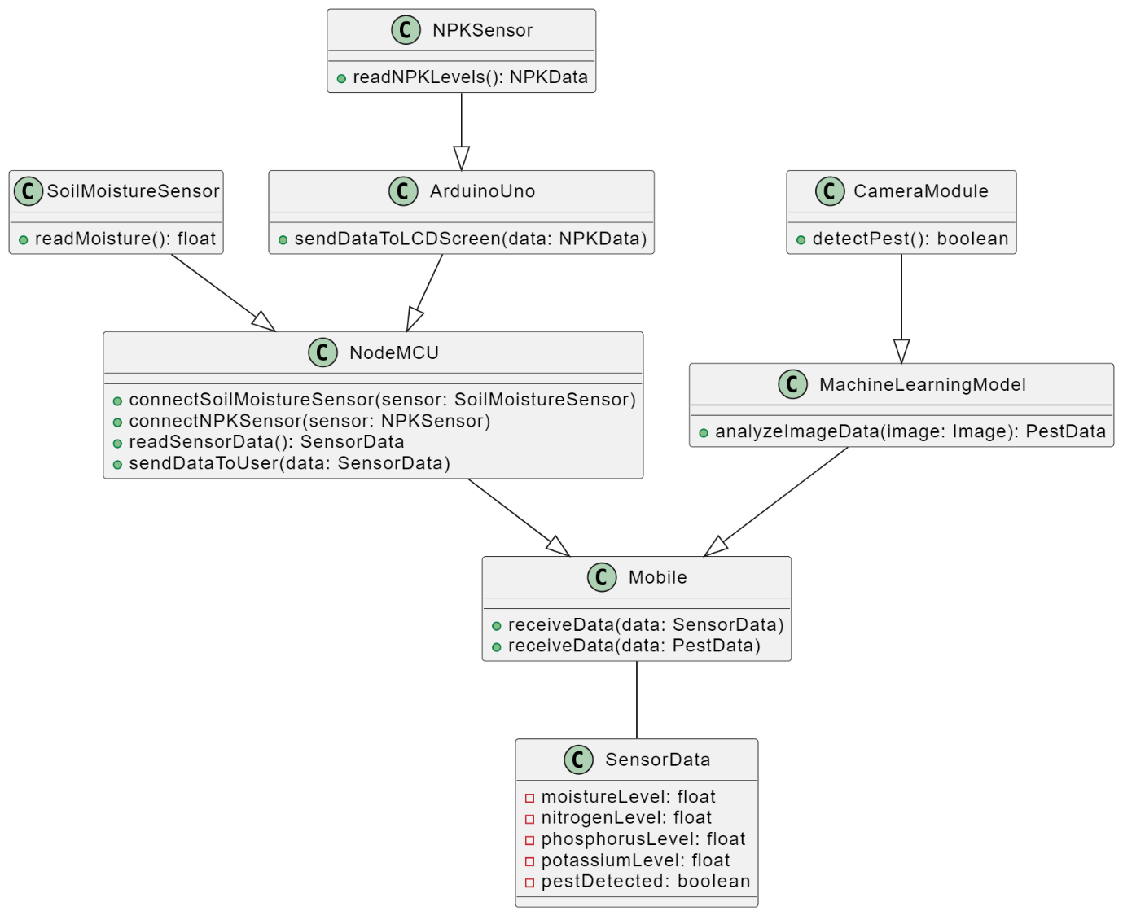 **Fig 5.1: System architecture**

The smart agriculture system comprises various components interconnected to facilitate efficient monitoring and management of crop conditions. The Soil Moisture Sensor functions as a critical element, measuring soil moisture levels and transmitting this data directly to the NodeMCU. Similarly, the NPK Sensor plays a pivotal role in assessing nitrogen, phosphorus, and potassium levels in the soil, with its data routed directly to the Arduino Uno and the NodeMCU for processing and display on an LCD screen.

The Camera Module is a central component responsible for capturing images of crops for pest detection. It bypasses the NodeMCU and sends these images directly to a pre-trained machine learning model based on InceptionV3 CNN architecture. This model analyzes the images to detect various diseases such as Bacterial Spot, Early Blight, Late Blight, Leaf Mold, Septoria Leaf Spot, Spider Mites, Two-Spotted Spider Mite, Target Spot, Tomato Yellow Leaf Curl Virus, and Tomato Mosaic Virus, as well as healthy plants. Once a disease is identified, notifications are sent to users via the Twilio library, alerting them to take necessary action.

The NodeMCU serves as the central hub connecting the sensors and managing data flow. It collects processed data from the Arduino Uno, including moisture and nutrient levels, and integrates this information with pest detection results from the machine learning model. The NodeMCU then transmits this comprehensive data set to the Blynk mobile application and the pest data is notified to the user via a SMS, offering real-time monitoring and control functionalities to users.

Overall, this system architecture optimizes crop management by seamlessly integrating sensor data collection, machine learning-based pest detection, and user-friendly mobile application interfaces, enabling precise and timely decision-making in agricultural practices.

**CHAPTER 6**

**IMPLEMENTATION**

**6.1: Soil Moisture monitoring and pumping**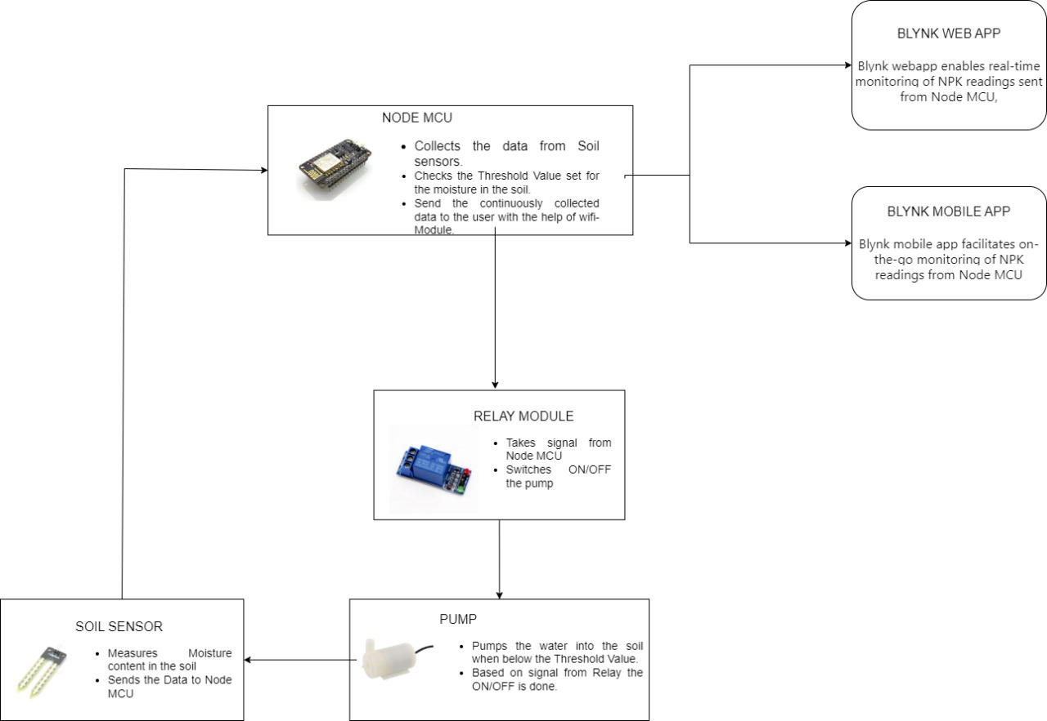

**Fig 6.1: soil moisture monitoring and pumping**

The AB054 Soil Moisture Sensor plays a pivotal role in the smart agriculture system by providing crucial insights into soil hydration levels. This capacitive sensor, connected to analog pin A0, continuously measures the moisture content in the soil. The readSoil() function processes the analog data from the sensor, converting it into a percentage value representing soil moisture ranging from 0% (dry) to 100% (saturated). This information is fundamental as it directly influences the soil's capacity to retain water, which in turn affects the growth, health, and productivity of tomato plants.

The NodeMCU serves as the central control unit orchestrating the soil moisture monitoring and irrigation processes. It establishes communication with the soil moisture sensor to fetch real-time moisture level data. This data is then transmitted to the Blynk app, a user interface platform, where it is displayed on virtual pin V0. The Blynk app provides users with remote access to monitor the current soil moisture percentage. This feature empowers users to stay informed about soil conditions without being physically present in the field, enabling proactive decision-making.

In tandem with soil moisture monitoring, the integrated water pump, controlled via digital pin D1, plays a crucial role in maintaining optimal soil moisture levels. The NodeMCU's logic dictates the pump's operation based on predefined moisture thresholds. When the soil moisture level drops below 20%, indicating dry soil, the NodeMCU activates the water pump to irrigate the soil and replenish moisture. Conversely, if the moisture level surpasses 80%, signaling excessive moisture, the pump is automatically turned off to prevent over-watering. This automated pumping mechanism ensures that tomato plants receive the right amount of hydration, fostering healthy growth and development while conserving water resources efficiently.

Furthermore, the inclusion of the Blynk app enhances user interaction and control over the irrigation system. Through the app's intuitive interface, users can remotely monitor not only the soil moisture levels but also the operational status of the water pump. This real-time monitoring capability facilitates quick decision-making and intervention. For instance, if the app detects deviations from the desired moisture range or pump malfunctions, users can take immediate corrective actions, such as adjusting irrigation schedules or addressing pump issues, ensuring optimal conditions for tomato cultivation.

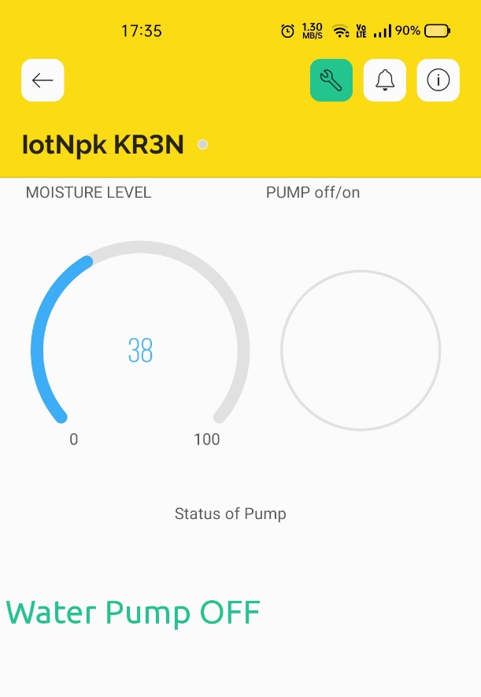

**Fig 6.2: Moisture of soil and status of pump displayed in Blynk app.**

The integration of the AB054 Soil Moisture Sensor, NodeMCU, and Blynk app in the smart agriculture system represents a sophisticated yet user-friendly approach to optimizing tomato cultivation. By leveraging real-time data on soil moisture levels and automating irrigation through the water pump, growers can ensure that tomato plants receive the precise amount of hydration needed for healthy growth and maximum yield. The seamless interaction between sensors, microcontrollers, and the Blynk app not only enhances monitoring and control but also empowers growers with actionable insights and decision-making capabilities, ultimately contributing to sustainable and efficient tomato farming practices.

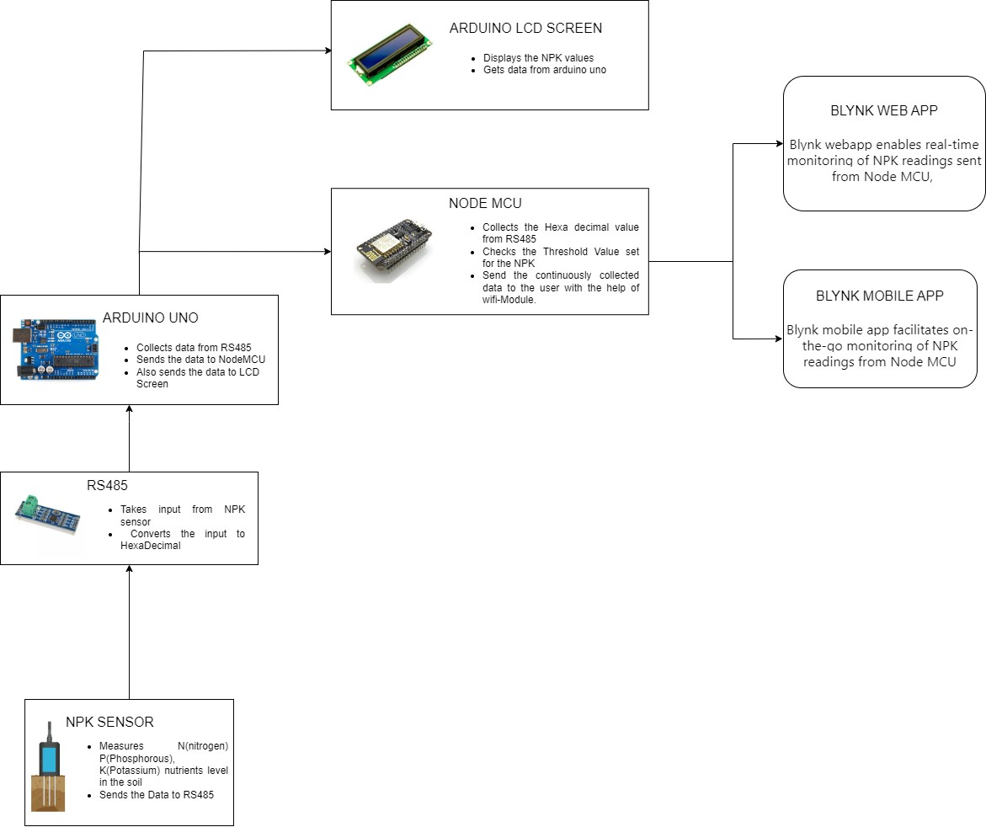**6.2 Soil Nutrients Detection**

**Fig 6.3: Soil nutrients monitoring and pumping**

NPK (Nitrogen, Phosphorus, Potassium) nutrients play a fundamental role in the growth, development, and overall health of tomato plants. Each of these nutrients serves specific functions critical to the plant's metabolic processes, and their deficiencies can have profound effects on plant growth and yield.

**Importance of NPK Nutrients**

1. **Nitrogen (N):** Nitrogen is essential for the synthesis of chlorophyll, which is crucial for photosynthesis. It promotes leafy growth, enhances plant vigor, and contributes to overall plant protein formation.
2. **Phosphorus (P):** Phosphorus is vital for energy transfer within the plant, root development, and flower and fruit formation. It also plays a role in enhancing plant resilience to environmental stress.
3. **Potassium (K):** Potassium regulates water uptake, improves nutrient transport within the plant, enhances disease resistance, and contributes to fruit quality, flavor, and shelf life.

**Effects of NPK Deficiencies**

1. **Nitrogen (N) Deficiency**: A lack of nitrogen leads to chlorosis, where older leaves turn yellow due to insufficient chlorophyll. It results in stunted growth, reduced fruit development, and overall plant weakness.
2. **Phosphorus (P) Deficiency:** Phosphorus deficiency causes dark green or purple leaves, poor root development, delayed flowering and fruiting, and smaller, underdeveloped fruits.
3. **Potassium (K) Deficiency:** Insufficient potassium leads to yellowing of leaf margins (necrosis), weak stems, increased susceptibility to pests and diseases, and poor fruit quality and yield.

The implementation of soil nutrients monitoring is a crucial component in ensuring the optimal growth and health of tomato plants within the smart agriculture system. Utilizing an NPK (Nitrogen, Phosphorus, Potassium) sensor, the system collects vital data on these essential nutrients levels in the soil. The NPK sensor's communication with an Arduino Uno microcontroller, facilitated by an RS485 module for data conversion, ensures accurate and reliable data collection in hexadecimal format.

Upon receiving the nutrient data, the Arduino Uno serves a dual function by transmitting this information to both the NodeMCU for further analysis and an LCD screen for real-time display. The NodeMCU, acting as the central processing unit, processes the NPK data and relays it to the user interface via the Blynk app. In the Blynk app, users gain insightful visualizations showcasing the percentage distribution of Nitrogen, Phosphorus, and Potassium in the soil. This feature empowers users with a comprehensive understanding of the soil's nutrient composition, aiding in informed decision-making for optimal plant nutrition management.

The integration of the Blynk app adds a layer of accessibility and control, enabling users to remotely monitor soil nutrient levels and make data-driven decisions. Real-time data visualization and customizable notifications empower users to proactively manage nutrient supplementation strategies, ensuring that tomato plants receive optimal nutrition for their development.

Moreover, the smart agriculture system incorporates customized NPK ratios tailored to different growth phases of tomato plants for optimal nutrient management. This approach ensures that the nutrient composition in the soil aligns with the specific requirements of tomato plants at various stages of their growth cycle. For instance, the Blynk app displays recommended NPK ratios suitable for each growth phase. During the vegetative growth phase (0-6 weeks), the recommended ratio might emphasize 20% Nitrogen, 10% Phosphorus, and 10% Potassium. As the plants transition into the fruit development stage (6-8 weeks), the ratio might adjust to 10% Nitrogen, 20% Phosphorus, and 20% Potassium. This adaptability to different growth phases optimizes nutrient uptake and supports healthy plant development.

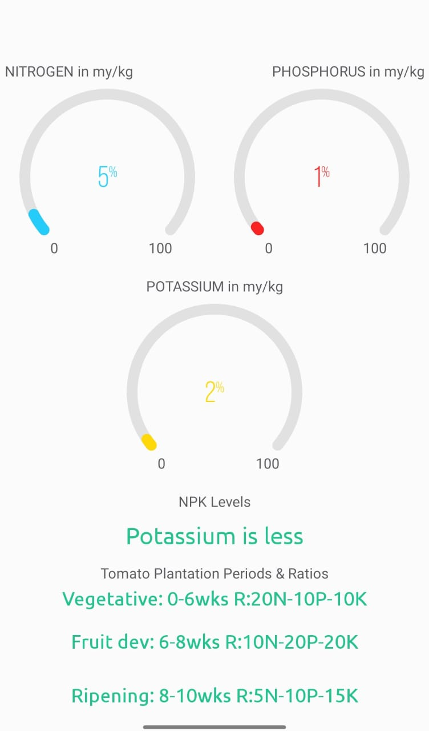

**Fig 6.4: Nutrients level in soil and Ratios of NPK at different growth phases in Blynk app.**

**6.3: Pest Detection and Disease Identification**

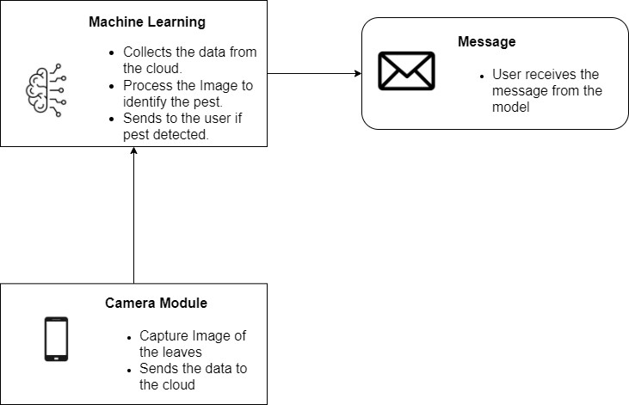

**Fig 6.5: Pest Detection and identification workflow.**

Pests in tomato plants can cause significant damage, leading to reduced yields and lower crop quality. Diseases like Bacterial Spot, Early Blight, Late Blight, Leaf Mold, Septoria Leaf Spot, and pests like Spider Mites and Target Spot are common threats. For instance, Bacterial Spot alone can cause up to a 60% reduction in yield if not managed effectively. Early detection of these pests and diseases is crucial because it allows farmers to take timely action, such as applying appropriate treatments or implementing pest control measures, to minimize losses.

The Automated Tomato Plant Disease Detection System was developed with the aim of automating the process of identifying these pests and diseases in tomato plants. This system is especially valuable in large-scale agricultural operations where manual inspection of each plant is impractical.

To create a reliable detection system, advanced machine learning techniques were employed. An InceptionV3-based Convolutional Neural Network (CNN) model was trained using a diverse dataset containing images of tomato plants affected by various pests and diseases, including the ones mentioned earlier. This training process involved labeling each image with the corresponding pest or disease to teach the model to recognize the visual patterns associated with each condition accurately.

The model is trained to identify a range of diseases commonly affecting tomato plants. These diseases include:

1. Bacterial Spot
2. Early Blight
3. Late Blight
4. Leaf Mold
5. Septoria Leaf Spot
6. Spider Mites
7. Target Spot
8. Tomato Yellow Leaf Curl Virus
9. Tomato Mosaic Virus

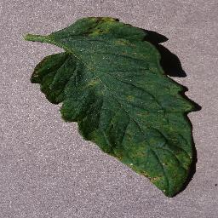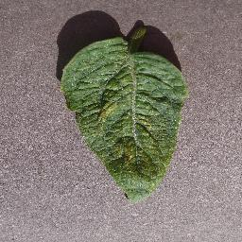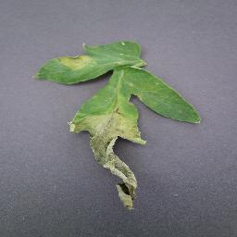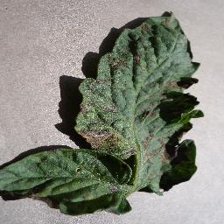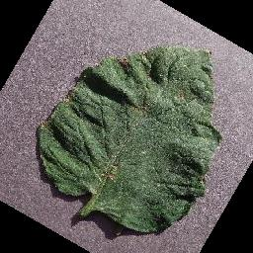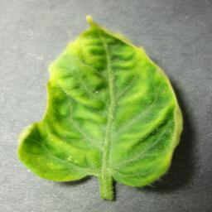

**Fig 6.6: Different types of pests of tomato plant.**

The model achieved an impressive accuracy rate of 90% for training data and over 87% during validation after training for 15 epochs, indicating its ability to differentiate between healthy plants and those affected by pests or diseases. This high accuracy is critical for minimizing false positives (misidentifying a healthy plant as diseased) and false negatives (failing to identify a diseased plant), ensuring that farmers receive reliable information for decision-making.

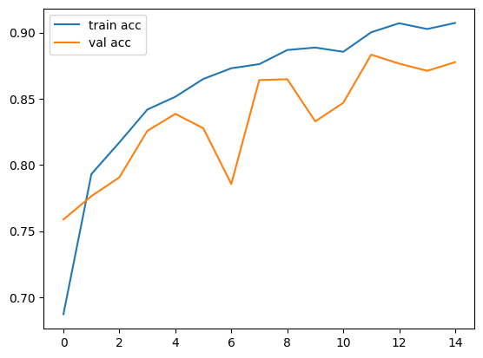

**Fig 6.7: Training and Validation accuracy**

The workflow of the system is intricately designed to maximize efficiency and automation, ensuring a seamless process from image capture to pest and disease detection, and finally, to notifying farmers for timely action. Here's a detailed breakdown of the workflow:

1. **MacroDroid App for Scheduled Image Capture:** The process begins with the MacroDroid app, which is set up to automate the capturing of images at regular intervals. This scheduled image capture eliminates the need for manual intervention, ensuring a continuous and consistent stream of data. This consistency is crucial for accurate analysis and monitoring of plant health parameters.
2. **Image Storage and Synchronization with Google Drive:** The captured images are automatically stored in a dedicated folder within Google Drive, chosen for its synchronization capabilities, ensuring that the images are seamlessly replicated across multiple devices. The synchronized data is accessible for analysis and processing.
3. **Watchdog Library for Triggering Image Processing:** The Watchdog library plays a vital role in the workflow by monitoring the designated Google Drive folder for any new image additions. When a new image is detected, the machine learning code is automatically triggered to process the image data. This ensures prompt action upon image capture, reducing processing delays and enhancing the system's responsiveness.
4. **Machine Learning Code and Trained CNN Model:** The machine learning code, integrated with TensorFlow and leveraging an InceptionV3-based Convolutional Neural Network (CNN) model, is responsible for analyzing the images. The trained CNN model has been specifically trained to identify common pests and diseases that affect tomato plants, such as Bacterial Spot, Early Blight, Spider Mites, etc. The model's predictions are based on the visual patterns learned during its training phase, ensuring accurate and reliable results.
5. **Notification Generation with Twilio:** Upon detecting signs of pests or diseases in the analyzed images, the system generates customized notification messages using Twilio's SMS functionality. These notifications are tailored to inform farmers promptly about the plant's health status and any identified issues. This real-time communication empowers farmers to take immediate and targeted actions, such as applying appropriate treatments or implementing pest control measures, to mitigate risks and preserve crop health.

The Automated Tomato Plant Disease Detection System combines advanced technologies like machine learning, automation, and real-time communication to empower farmers with early and accurate pest and disease detection capabilities. By leveraging these technologies, farmers can proactively manage pest infestations, protect crop health, and optimize overall productivity in tomato cultivation.

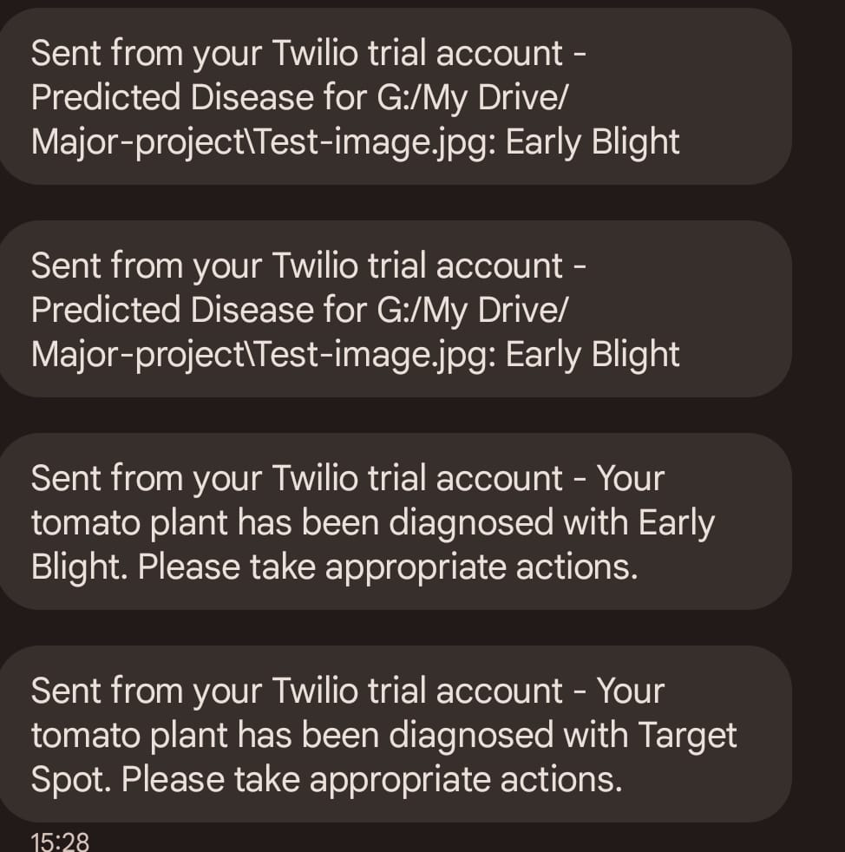

**Fig 6.8: Outcome of the predicted disease is sent to the user via SMS**.